1) What is HTML stand for? (1 mark)

|  |
| --- |
| Hyper text markup language |

2) What is the different between website and web page? (1 mark)

|  |
| --- |
| A web page is one page on the screen, a website can have multiple web pages |

3) Write the basic tag for red Arial text with 30 pixels for HTML body. (4 marks)

|  |
| --- |
| <font family=arial color=red px=30> |

4) What is the default table tag look like for 2 columns and 1 row? (4 marks)

Note: you need to include correct open and close tags for **table**.

|  |
| --- |
| <table>< tr> < td></td > <td ></td > </tr ></table> |

5) There are only 2 tags that do not need a closing tag. Name them. (2 marks)

|  |  |
| --- | --- |
| <img> | <br> |

6) How do you write the bullet points and numbering in HTML with 2 items? (6 marks)

|  |  |
| --- | --- |
| <li>  <li> | <nli>  <nli> |

7) The following code has some errors, please correct them. (Hard Level) (10 marks)

PS: only Here is clickable on line 3.

|  |  |
| --- | --- |
| <HTML> <body bgcolour=green> <centre> | <html> <body bgcolor=green> <center> |
| <B> Welcome to my website. </strong> | <b> welcome to my website.</b> |
| Click here for BBC. <a = bbc.co.uk> | <a href=bbc.co.uk> Click here for BBC. <a> |
| </body bgcolour></centre></html> | </body> </center> </html> |

8) Write the HTML tag based on the screen shot below. (Hard Level) (8 marks)

Pay attention to the detail of the screenshot and look at how they are aligned and appear in the table.

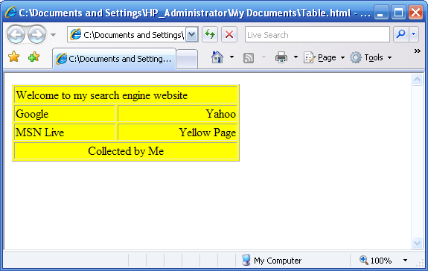

<html> <table bgcolor=yellow border=1>

**<tr><td >** Welcome to my search engine website **</td ></tr>**

**< tr> < td>** Google **</td > <td align=right >** Yahoo **</td > </tr >**

**< tr> <td >** MSN Live **</td > <td align=right >** Yellow Page **</td > </tr >**

**< tr> <td align=middle >** Collected by Me **</td > </ tr>**

</table></html>

9) Write the Hyperlink code for linking to the BBC website. (2 marks)

|  |
| --- |
| **<a href=bbc.co.uk> <a>** |

10) Add an image file called bbc.jpg on the web page with width 300 pixels. (2 marks)

|  |
| --- |
| <img src=bbc.jpg width=300> |

11) Put background image called bg.png for the whole web page? (1 mark)

|  |
| --- |
| <body bg=bg.png> |

12) Draw a layout of the HTML code below and add comments on each line.

Note: Try to explain the keywords/tags in red colour. (10 for comment + 3 for layout)

What will it look like if you copy the code below to create the web page? Draw it in the space provided.

<html> tells the computer to read as html code

<body bgcolor=white> background colour is white

<title> Google </title> the title is google

<center> make everything in the centre

<br> <marquee width=50%>Welcome to Google </marquee> <br> makes the message welcome to google scroll from the right quarter of the screen to the left quarter and skips a line

<a href="http://www.google.com"> <img src=logo.gif border=0> </a> <br> makes the gif of the logo without a border link to google and skips a line

<FORM method=GET action="http://www.google.com/search"> when search is pressed, sends user to google

<INPUT type=text size=50> input box with text size 50

Google

Welcome to google

Logo here

Input here

Search here

Clear here

<INPUT type=submit value="Search"> button that says

search

<INPUT type=reset value="Clear"></FORM>

Reset button called clear

</center></body> closes center and body tags

</html> tells computer this is the end of the html code

13) What is CSS stand for? What does it do with example? (2 marks)

|  |  |
| --- | --- |
| Cascading style sheets | It compliments html to add style, for example by spinning images |

14) What is JS stand for? What does it do with example? (2 marks)

|  |  |
| --- | --- |
| javascript | It supplements html by providing a more versatile programming languaghe |

15) What is the main benefit of separating CSS and JS file from the HTML file? (2 marks)

|  |
| --- |
| They apply to all webpages they are linked to |

16) How do you link those CSS and JS file into HTML file? (2 marks)

|  |
| --- |
| CSS link <ref stylesheet=css.css> |
| JS link |

17) Explain the different between ID and class in HTML? (2 marks)

|  |  |
| --- | --- |
| ID = for js to apply to | Class = for css to apply to |

18) Make the following text (Hello! Google) into paragraph, bold text, blue colour, Calibri type and centre alignment on the screen. Google needs to link to actual Google website. (10 marks)

Note: you need to include correct open and close tags. (Very Hard Level)

**<html > <body > <p >**

**< a href=google.com > <b > hello! Google </b > </a >**

**</ p> </body > </html >**

19) Write CSS code for making the whole page yellow colour, heading in blue with centre alignment and paragraph in green and font type with Ariel and font size 10. (10 marks)

<style>

.bg{bgcolor:yellow;}

.h{color:blue; align:center;}

.p{font face:ariel; size:10; color:green;}

</style>

20) There are mistakes in the following CSS code. Please correct them in the right column. (6 marks)

|  |  |
| --- | --- |
| Code with error | Rewrite to the Correct Code |
| H1 ( font align = center color = white) | H1{font align:center; color:white;} |
| P [ font style = verdana size = 20px ] | P1{font face:verdana; size:20px;} |

Total = ____________/ 90